Name______________________
Please use the Dictionary app on your ipad to find at least two synonyms for each of the following words.
Sad _________ __________
Surprised _________ _________
Angry _________ ___________
Happy __________ __________
Frightened _________ _________

Name______________________

Please use the Dictionary app on your ipad to find at least two synonyms for each of the following words.
Sad _________ __________
Surprised _________ _________
Angry _________ ___________
Happy __________ __________
Frightened _________ _________
Flickr Directions:
Use the camera on the ipad to take a picture of a member in your group making a face to describe each of the words you found synonyms for. Use Flickr to upload the photos by following the directions below.
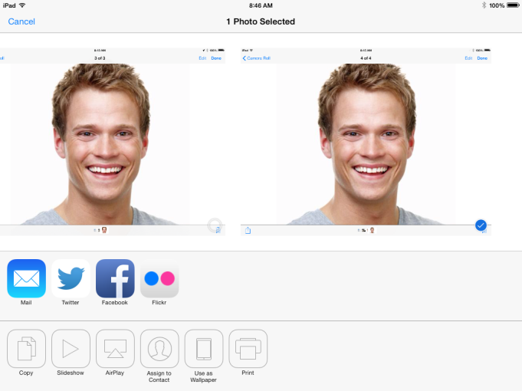
Find the pictures in your camera roll.

1. Click on the upload button 2. Select the Flickr icon
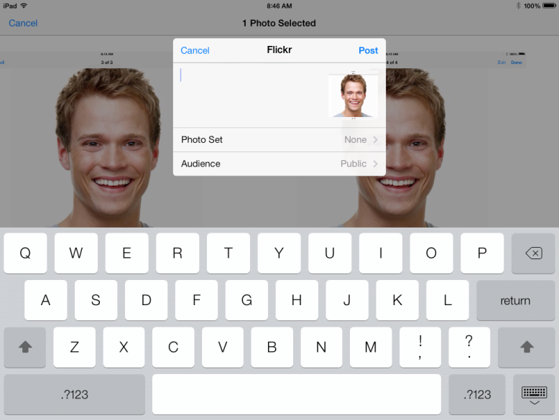

Select “Post”
This will bring you back to the camera mode. Select another picture and start the steps again.

This will bring you back to the camera mode. Select another picture and start the steps again.
This will bring you back to the camera mode. Select another picture and start the steps again.

3. Select Done
3. Select Post
SELECT POST
Notes to the teacher:
After students upload their pictures, you can view them through our Flickr account.
Go to flickr.com and click on sign in.
CEC Students
Yahoo ID – studentcec
Password – 2900SACsce

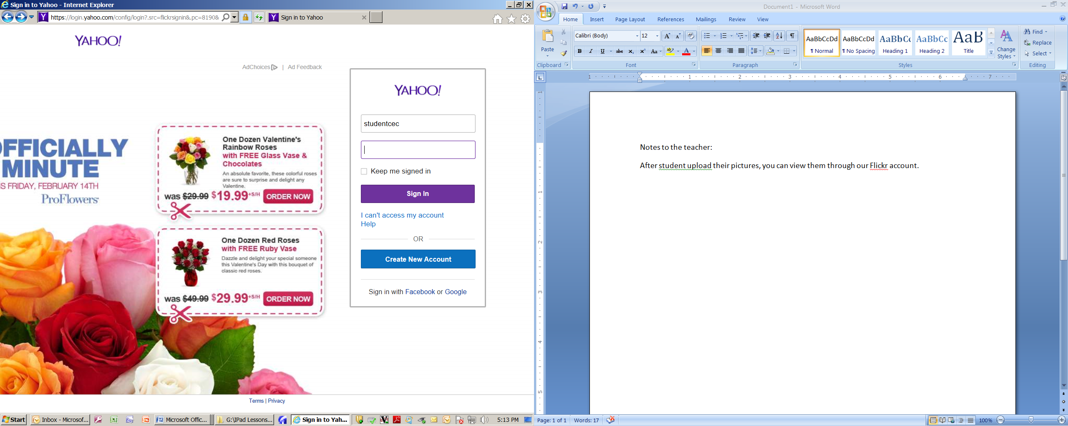

2900SACsce

