Notes to the teacher:
After students upload their pictures, you can view them through our Flickr account.
Go to flickr.com and click on sign in.
Yahoo ID – studentcec
Password – 2900SACsce

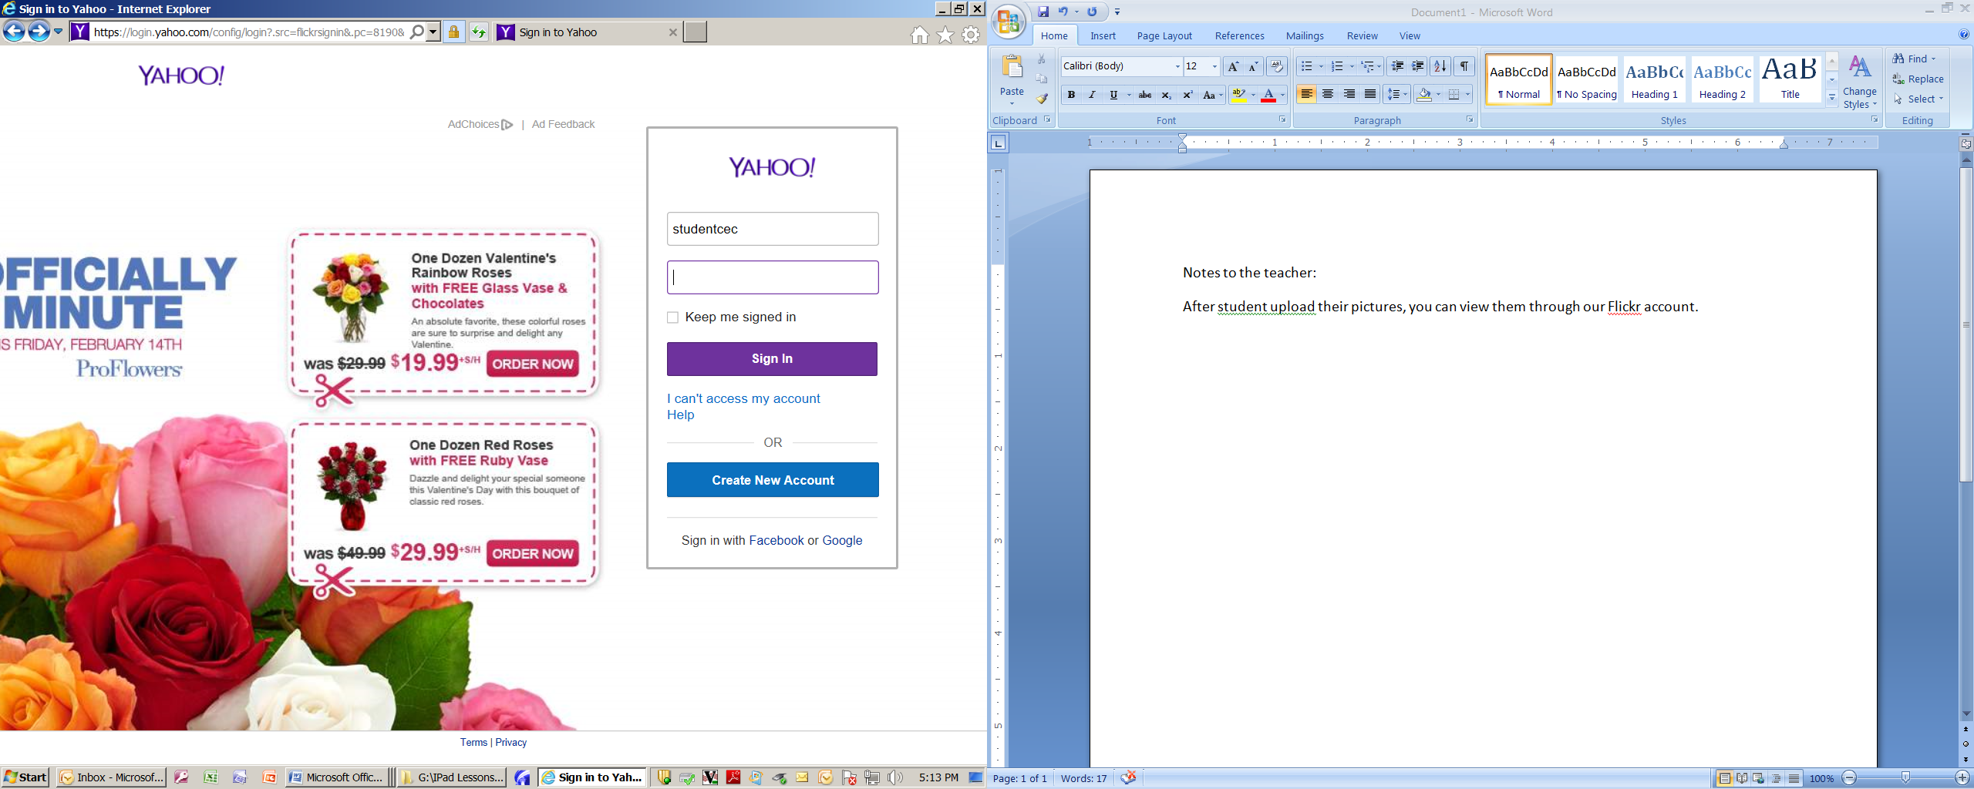

2900SACsce

